Chapter 6
- N-Queens Visualization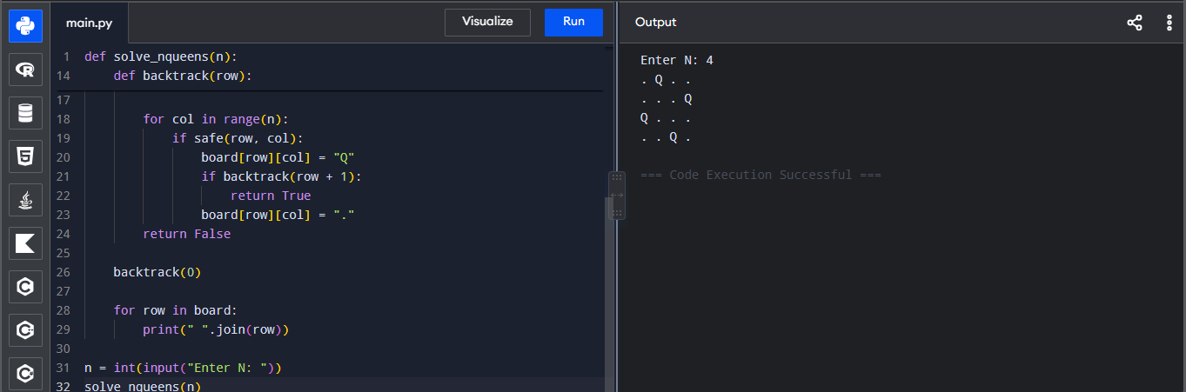
- Generalized N-Queens – 8×10 Board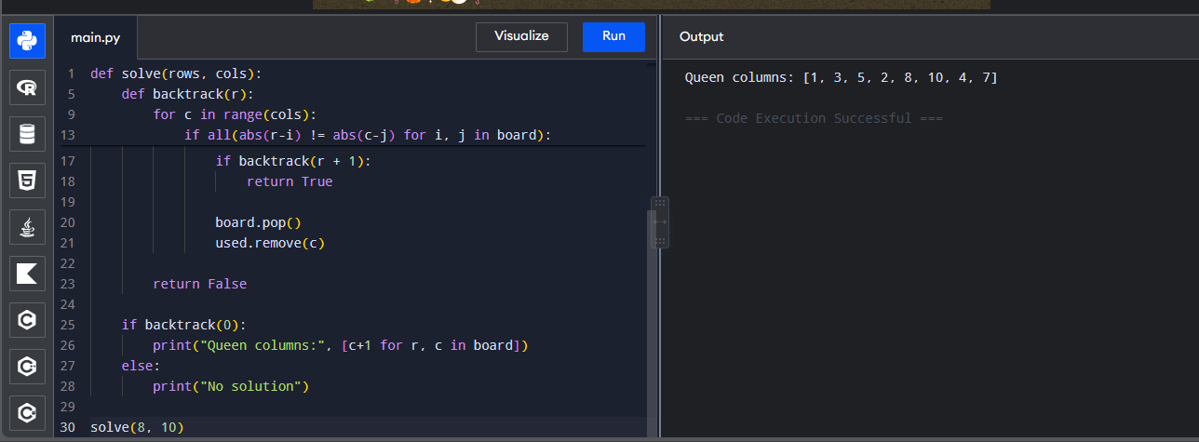
- Sudoku Solver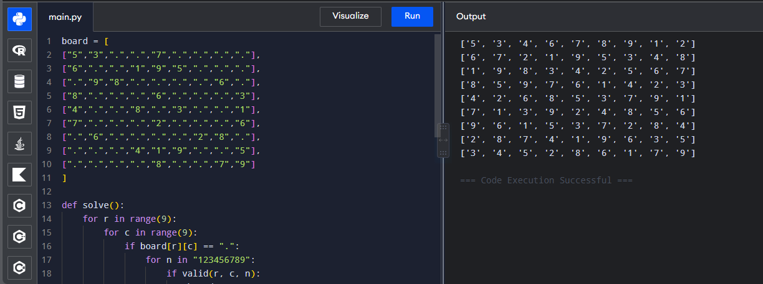

- Sudoku Solver
- Target Sum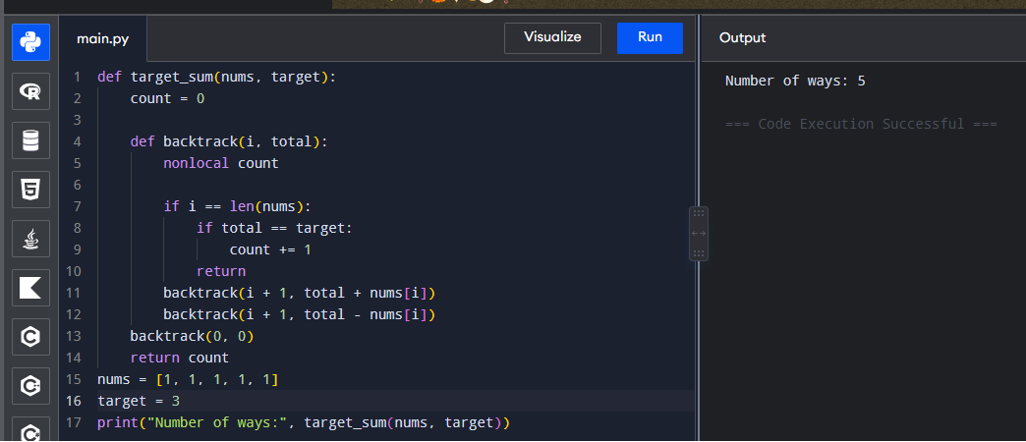
- Combination Sum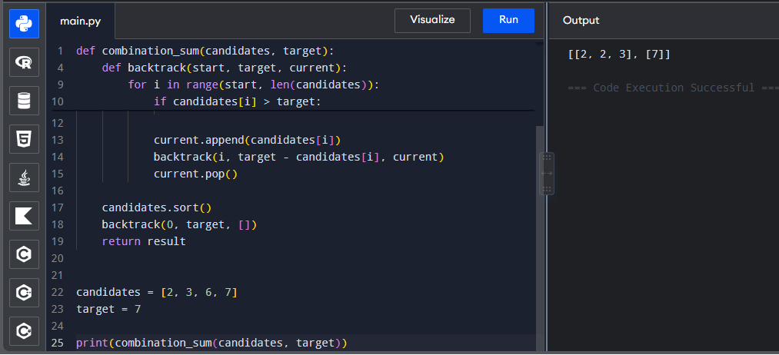

7.Combination sum 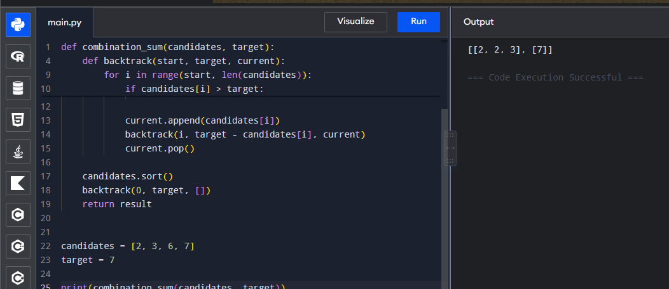
8. Combination Sum II
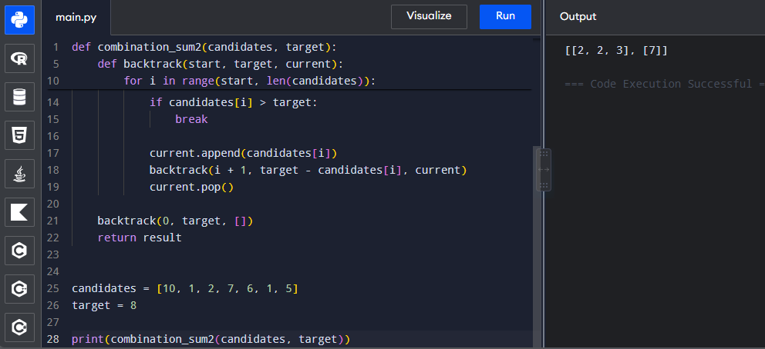
9. Permutations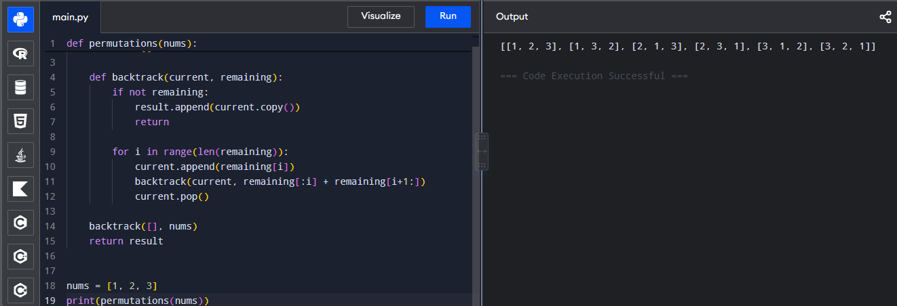

10. Unique Permutations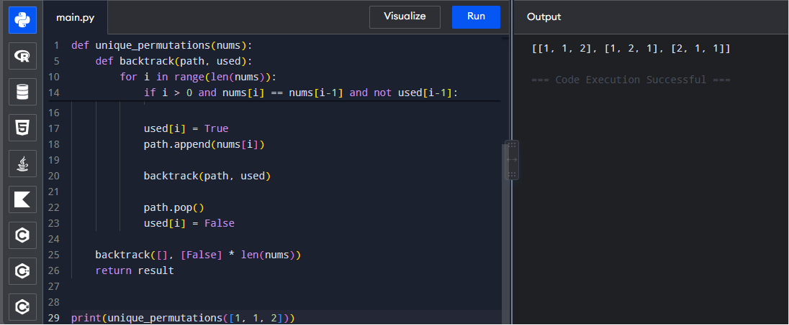
11. Graph Coloring – Minimum Colors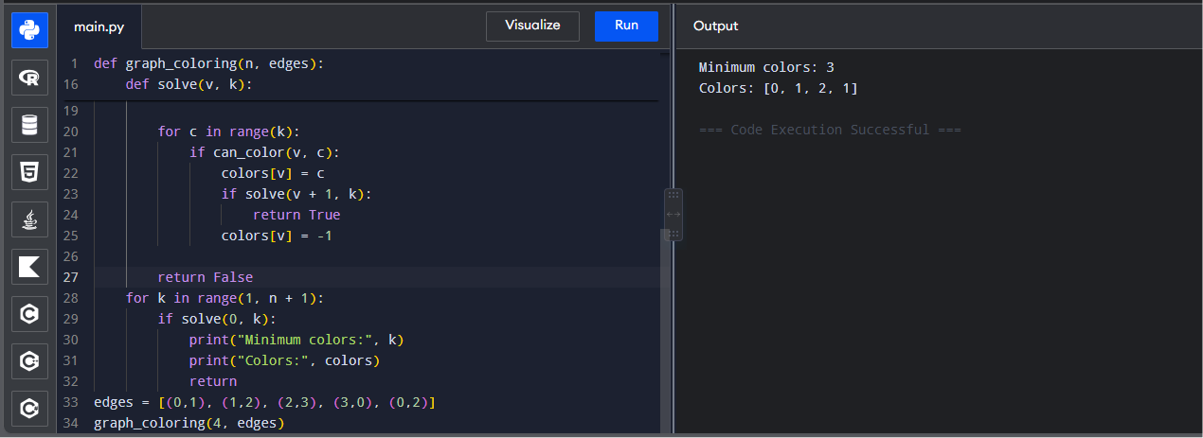
12. Graph Coloring with K = 3
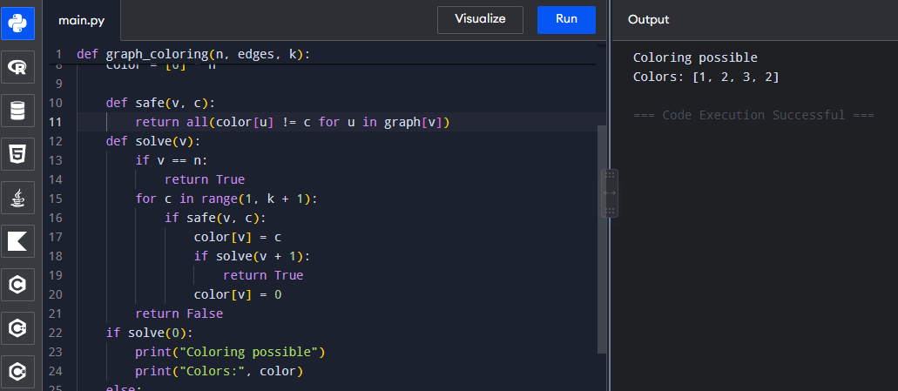

13. Hamiltonian Cycle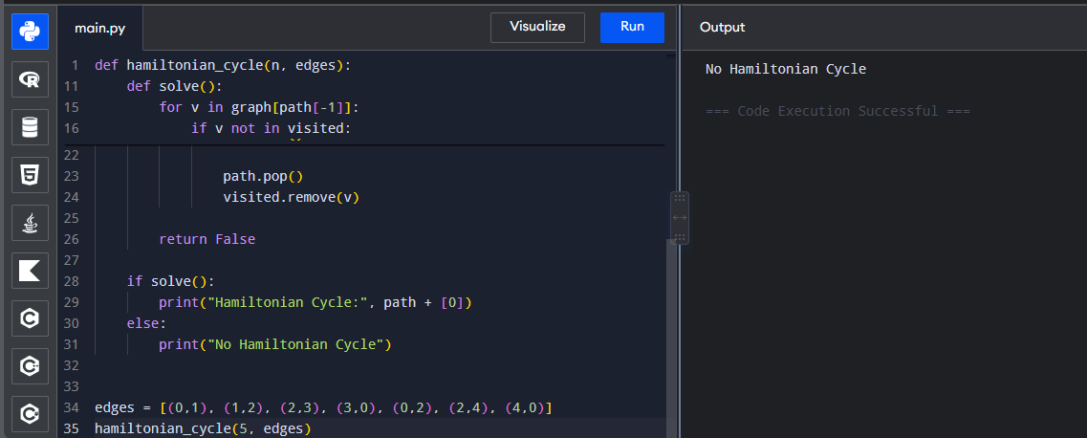
14. Hamiltonian Cycle
15. Generate All Subsets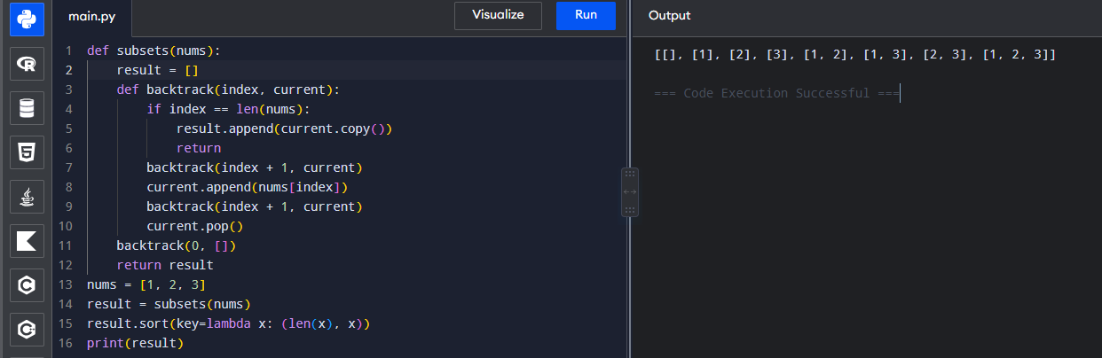

16. Subsets Containing 3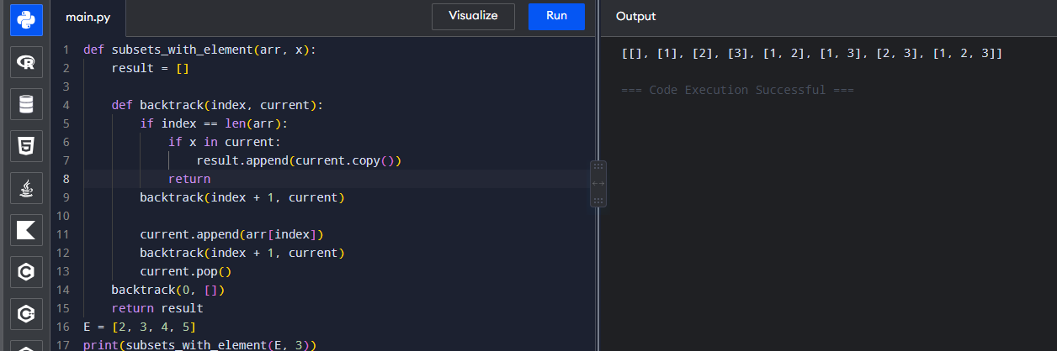
17.Word subsets
